Objectives: JavaFX and Database

**There are 2 projects, each worth 50%**

**Project #1**

Complete the following programs using JavaFX and submit the output or results to a table using Derby or any other database system.

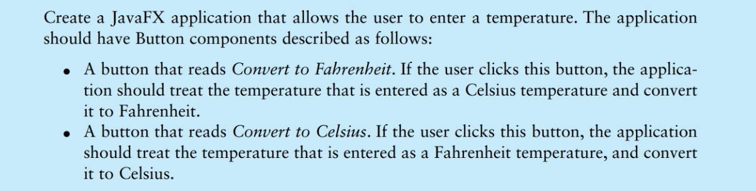

**#1 print screen the output with the code below here**

**Project #2**

Complete the following programs using JavaFX and submit the output or results to a table using Derby or any other database system.

**#2 print screen the output with the code below here**

**Submit this document to Module 09 Homework #9**